# Customizing and Adapting the Python VIE

## Example Set: Controlling the vMPL

### Example 1: Use the PythonVIE to control the vMPL in Unity:

Note: Run this from the /python/minivie/ folder. For windows, use py -3; for linux, use python3

python3 -c "from mpl.unity import UnityUdp; s = UnityUdp(); s.connect(); s.send_joint_angles([0,0,0,1.57,0,0,0]); s.close()"

This sends the elbow to 90 degrees.

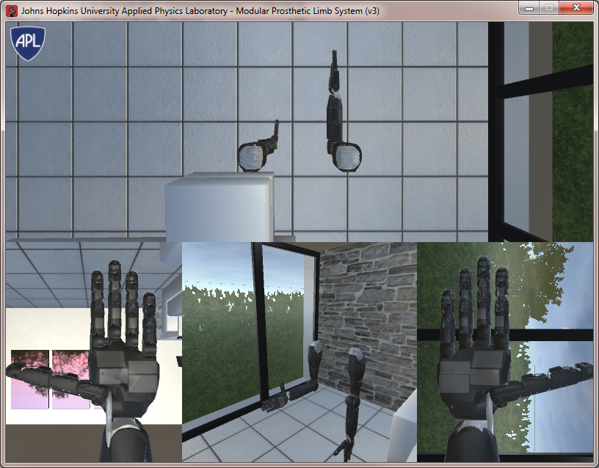

It imports the module, creates a udp command class, connects, then sends the joint angles (to the 7 upper arm joints, in radians).

### Example 2: Control a second vMPL arm

This repeats the example using the left arm command (and feedback) ports

python -3 -c "from mpl.unity import UnityUdp; s = UnityUdp(remote_address='//127.0.0.1:25100', local_address='//127.0.0.1:25101'); s.connect(); s.send_joint_angles([0,0,0,1.57,0,0,0]); s.close()"

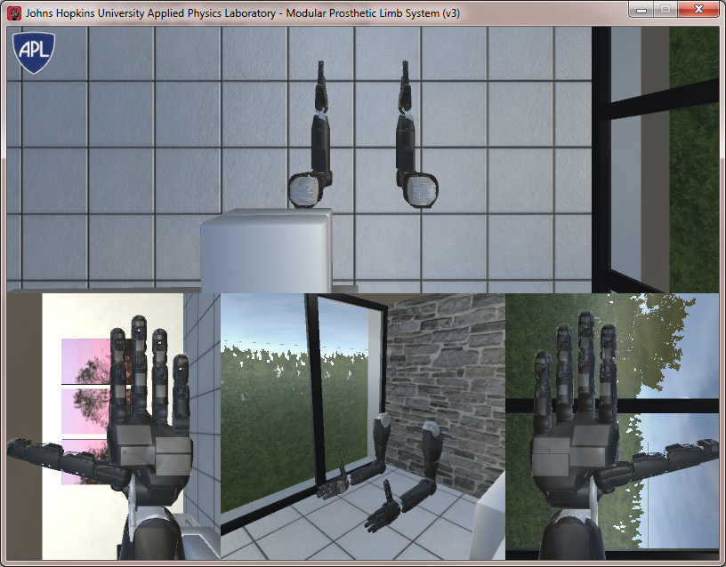

### Example 3: Create a script to control specific joints

Move all joints, and use joint id to specify Index metacarpophalangeal joint:

my_script.py:

**from** mpl.unity **import** UnityUdp  
**from** mpl **import** JointEnum **as** MplId  
  
s = UnityUdp(remote_address=**'//127.0.0.1:25100'**, local_address=**'//127.0.0.1:25101'**)  
s.connect()  
  
angles = [0.0] * 27  
angles[MplId.INDEX_MCP] = 1.57  
  
s.send_joint_angles(angles)  
s.close()

python3 my_script.py

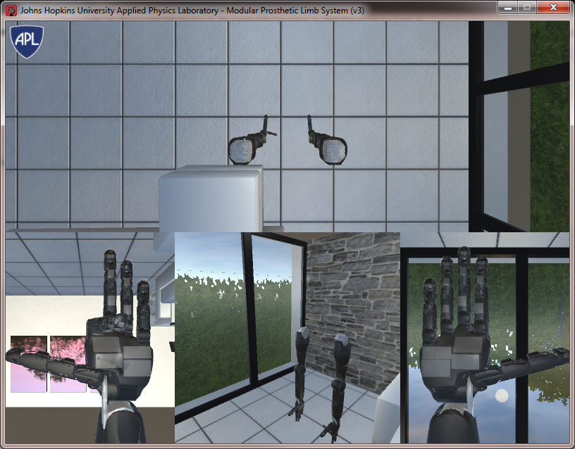

## To Be continued…